**23CSE111**

**OBJECT ORIENTED PROGRAMMING**

**LAB REPORT**



**Department of Computer Science Engineering**

**Amrita School of Engineering**

**Amrita Vishwa Vidyapeetham, Amaravati Campus**

**Name:** U. Sai. Rama. Mokshajna

**Verified By: Roll No:** AV.SC.U4CSE24340

|  |  |  |  |  |
| --- | --- | --- | --- | --- |
| **S.No.** | **Experiment Name** | **Page No.** | **Remarks** | **Signature** |
| 1 | Installation Process of JDK in the personal systems | 3 |  |  |
| 2 | Simple Java Program for printing basic details of student like name, section, id number | 5 |  |  |
| 3 | Simple java programs with user wanted values | 8-15 |  |  |
|  |  |  |  |  |
|  |  |  |  |  |
|  |  |  |  |  |
|  |  |  |  |  |
|  |  |  |  |  |

**WEEK-1**

Task-1:Installization of java programming language.

Steps:

1. Browse and Open oracle website in which we can install java language.

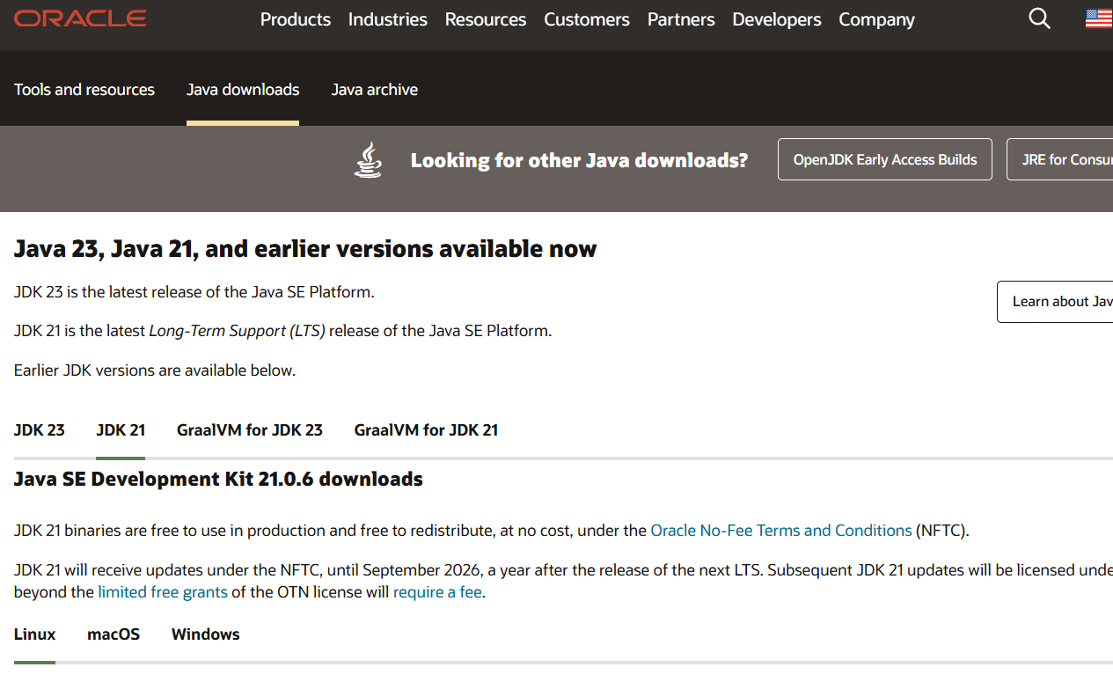

1. Install jdk 21 according to your system capability.

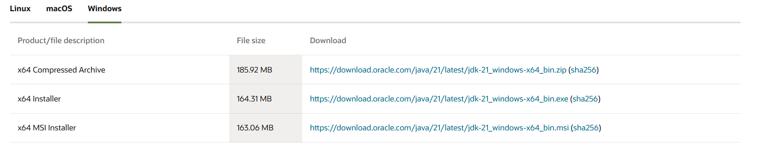

1. After installing .you can check it in this PC \program file document.
2. Now open command prompt and check the version with keyword “javac --version”.

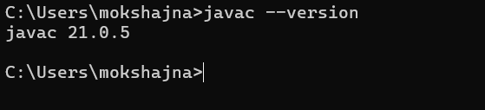

1. Now click all this files in order



1. Now copy the path in the above bar.
2. Now go to system search bar and search system environmental variables.

Open the environmental variable option.

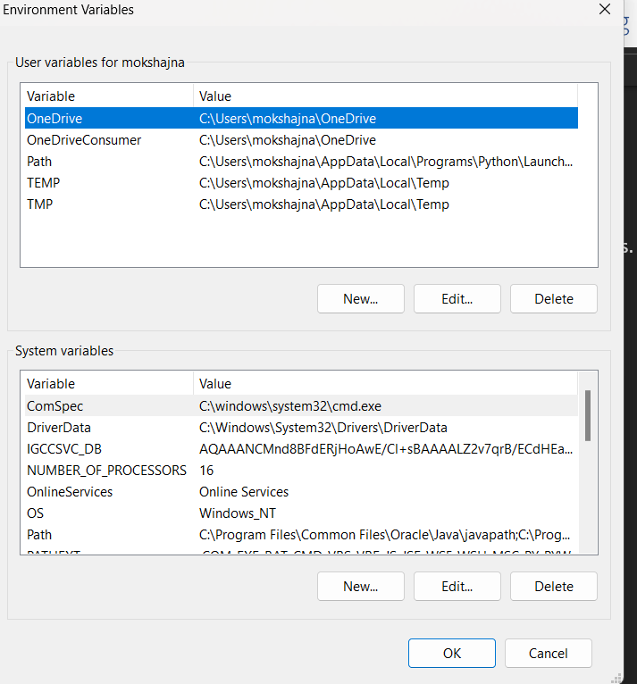

1. Now select the path function in system variable option and paste the path copied earlier in it.

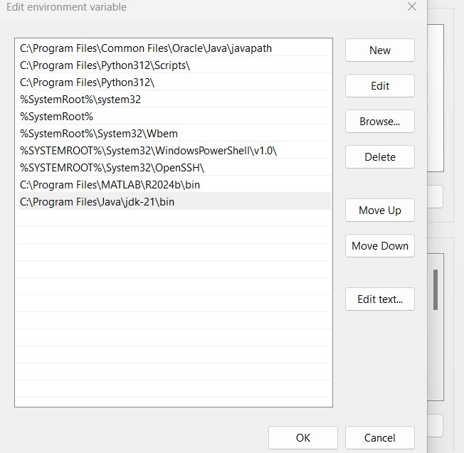

1. Now finally check version again in cmd using keyword “java --version”.it gives

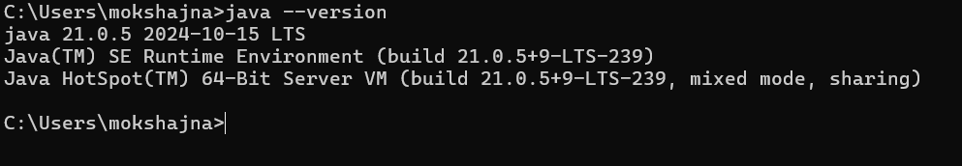

Task-2:

Preparing and executing program for printing details using java programming language.

Code:

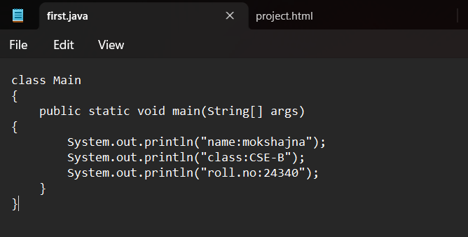

Execute:

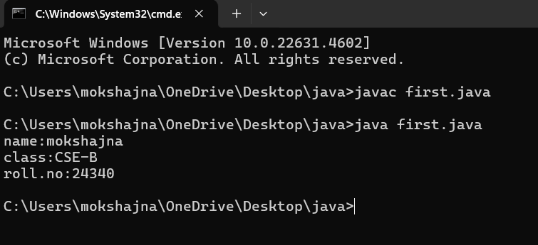

1. By using javac we will compile the first.java file and then
2. We used java for execution.

**Errors:**

|  |  |  |
| --- | --- | --- |
| S.No | error | Error rectification |
| 1 | Error: cannot find symbol | Giving correct spelling and capitals where it needed |
| 2 | Error: ”;” expected | Giving the ‘;’ in wanted places |

1. Error due to syntax problem

Code:

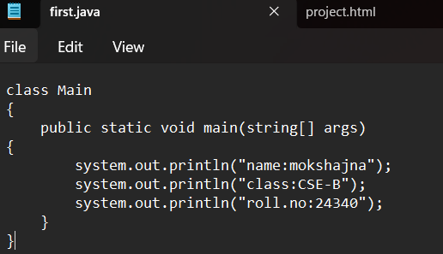

Execution:

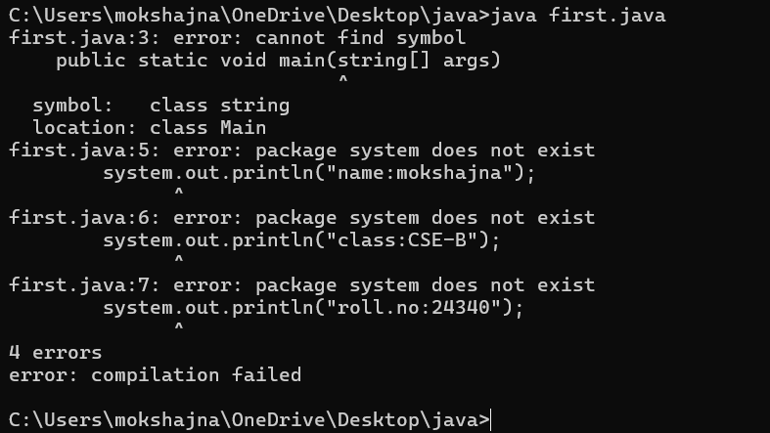

1. Error due to forgetting “;”

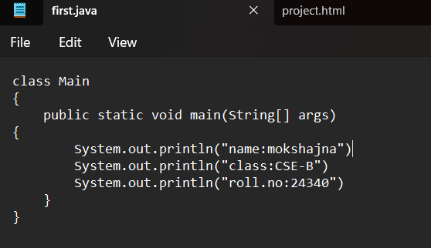

Execution:

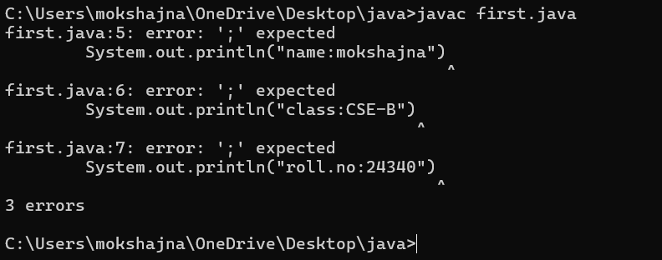

**WEEK-2**

Task-1:Write a java program to calculate the simple interest for user wanted details?

Sol

Program -

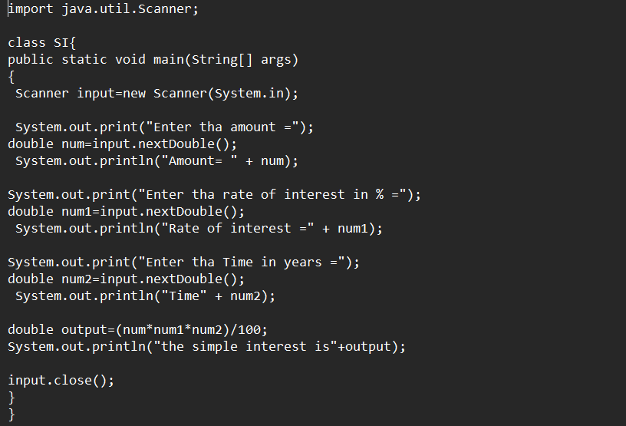

Output –

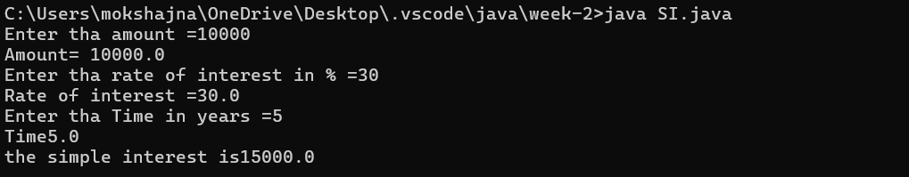

Error Table -

|  |  |  |
| --- | --- | --- |
| s.no | Error | Rectification |
| 1 | Error : cannot find symbol | Here in nextdouble()  D should be capital  Or else it is not considered as data type |
| 2 |  | Here in above all the variables are in double data types so the output must be double for code flexibility |

Task-2:Write a java program to calculate the Area of rectangle for user wanted details?

Sol

Program -

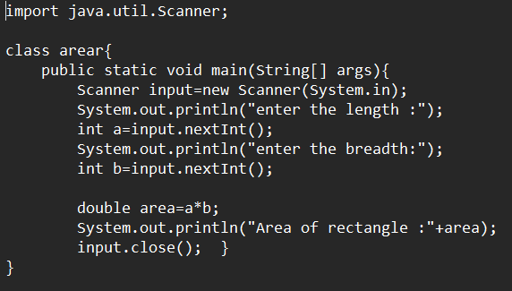

Output –

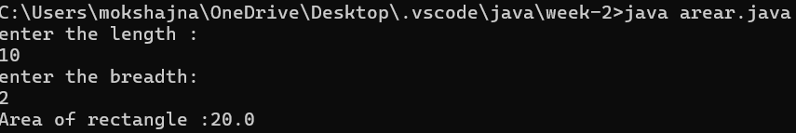

Error Table -

|  |  |  |
| --- | --- | --- |
| s.no | Error | Rectification |
| 1 | We can get symbol not found error means the system can’t find given symbols. | Here in nextInt()  I should be capital  Or else it is not considered as data type |
| 2 | Here we use a,b values as int so we should int values. | Here we should give input values as int domain values. |

Task-3:Write a java program to calculate the Area of triangle for user wanted details?

Sol

Program - 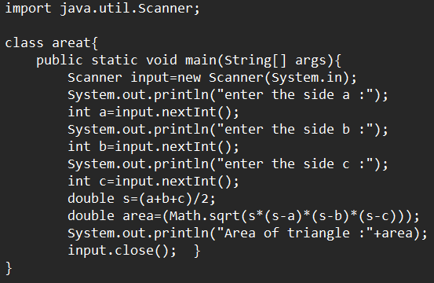

output –

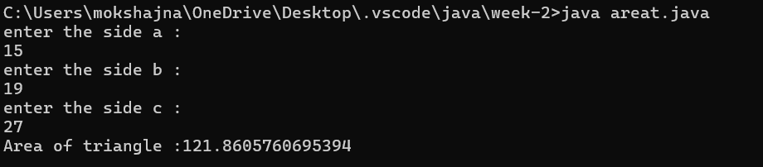

Error Table -

|  |  |  |
| --- | --- | --- |
| s.no | Error | Rectification |
| 1 | Here at output we may end up getting  Error at end product. | We should use float or double datatypes. |
| 2 | Here we can get wrong value at the end | We should make sure that we should give correct indentation Math.sqrt (s*(s-a)*(s-b)*(s-c)). |

Task-3:Write a java program to calculate the factorial for user wanted numbers?

Sol

Program - 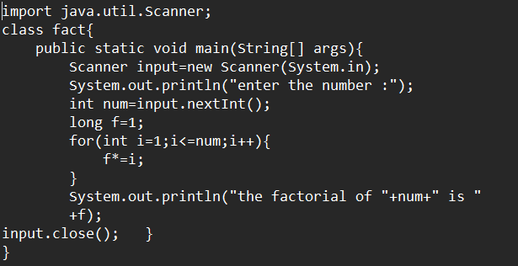

output –

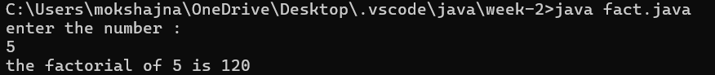

Error Table -

|  |  |  |
| --- | --- | --- |
| s.no | Error | Rectification |
| 1 | Here at output we may end up getting  Error at end product. | We should prefer using the  Long datatype for could flexibility |
| 2 | Error in recursion may possible | We should make sure that  The recursion steps be prefect. |

Task-4:Write a java program to calculate the Fibonacci series for user wanted numbers?

Sol

Program - 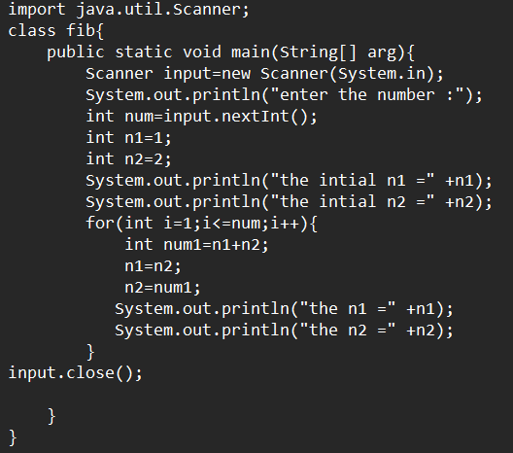

output –

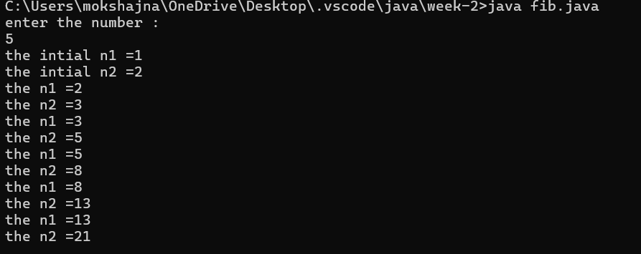

Error Table -

|  |  |  |
| --- | --- | --- |
| s.no | Error | Rectification |
| 1 | We might end up getting wrong output  at the end. | Make sure variables are correctly assigned |
| 2 | Error in recursion steps | We should make sure that  The recursion steps be prefect. |

Task-5:Write a java program to calculate the temperature of Celsius to Fahrenheit for user wanted numbers?

Sol

Program – (1) Celsius to Fahrenheit-

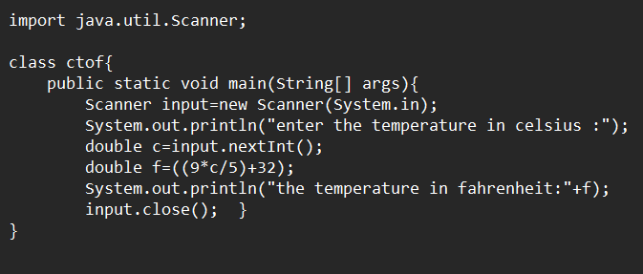

output –

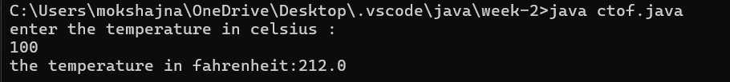

Error Table -

|  |  |  |
| --- | --- | --- |
| s.no | Error | Rectification |
| 1 | Error in datatypes . | Make sure variables are double or float datatypes. |
| 2 | We might end up with wrong values at the output | We should make sure that  Brackets and multiplication  Symbols at correct order. |

Task-6:Write a java program to calculate the temperature of Fahrenheit to Celsius for user wanted numbers?

Sol

Program – (1) Fahrenheit to Celsius -

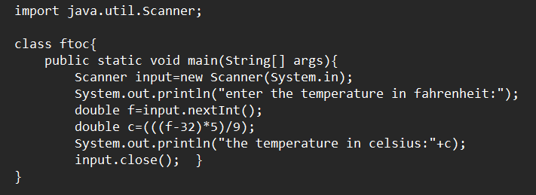

output –

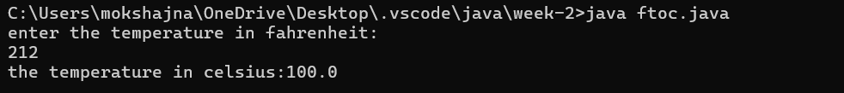

Error Table -

|  |  |  |
| --- | --- | --- |
| s.no | Error | Rectification |
| 1 | Error in datatypes . | Make sure variables are double or float datatypes. |
| 2 | We might end up with wrong values at the output | We should make sure that  Brackets and multiplication  Symbols at correct order. |

**WEEK-3**

Task-1: Create java program with following requirements.

a. Create a class with name Car.

b. Create four attributes named car_color,car_brand,fuel_type,

mileage.

c. Create three methods named start(),stop(),service().

d. Create three objects named Car1,Car2,Car3.

**CODE:**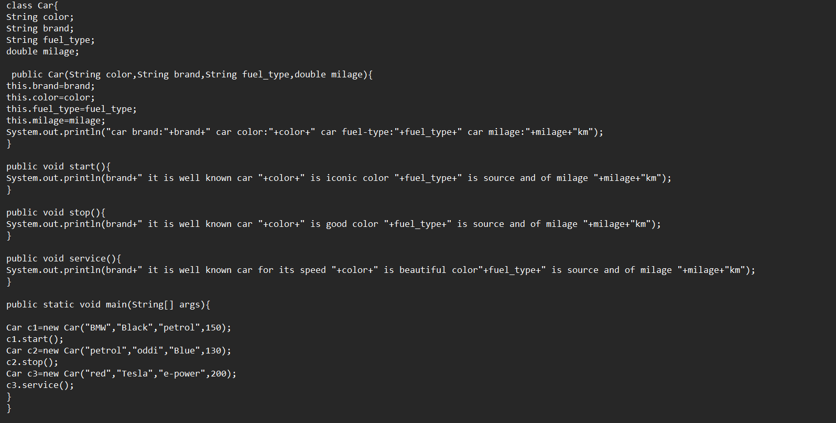

output –

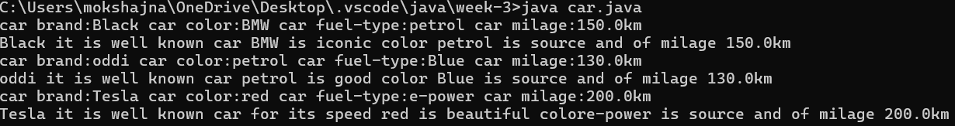

Error Table -

|  |  |  |
| --- | --- | --- |
| s.no | Error | Rectification |
| 1 | “;” expected. | Always end a statement with “;”. |
| 2 | Make sure the method name is different | Name them differently cause when call method system may get confused. |

**Class-Diagram-**

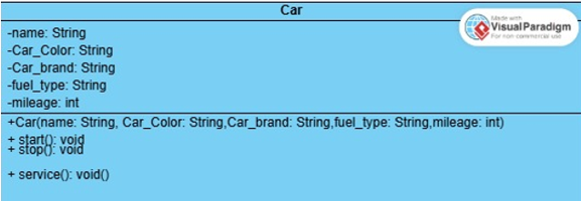

**Task-2: To create a class bank account with methods deposit() and withdrawal () with user friendly details.**

**CODE:**

import java.util.Scanner;

class Bank_account{

long current_balance;

String name;

String account_number;

String IFSE;

String branch;

Scanner input=new Scanner(System.in);

public Bank_account(long current_balance,String name,String account_number,String IFSE,String branch){

this.current_balance=current_balance;

this.name=name;

this.account_number=account_number;

this.IFSE=IFSE;

this.branch=branch;

System.out.println("User name:"+name+" account_number:"+account_number+" IFSE details:"+IFSE+" branch number:"+branch);

}

public void deposit(){

System.out.println("enter the depositing amount: ");

long deposit_amount=input.nextLong();

long sum=current_balance+deposit_amount;

System.out.println("the current blance after depoisting is "+ sum);

}

public void withdraw(){

System.out.println("enter the withdrawing amount: ");

long withdraw_amount=input.nextLong();

long dum=current_balance-withdraw_amount;

if(dum>0){

System.out.println("the current blance after withdrawal is "+ dum);}

else{

System.out.println("the current blance is insufficent ");

}

}

public static void main(String[] args){

Scanner input=new Scanner(System.in);

System.out.println("enter the Balance amount: ");

long amount=input.nextLong();

Bank_account a1=new Bank_account(amount,"moksha","123456789","abcd","533432");

a1.deposit();

System.out.println("enter the Balance amount: ");

long amount1=input.nextLong();

Bank_account a2=new Bank_account(amount1,"honey","961","abcd","533432");

a2.withdraw();

}

}

**OUTPUT:**

**Case-1:**

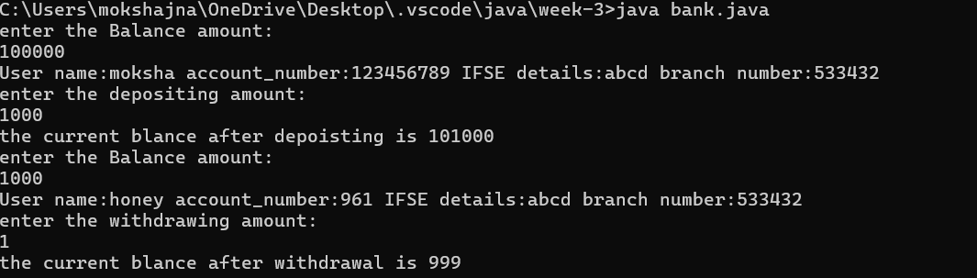

**Case-2**

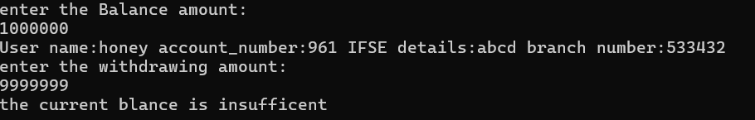

**ERROR:**

|  |  |  |
| --- | --- | --- |
| **S.No** | **Error** | **Rectification** |
| **1.** | **Error: Main method not found.** | **Main method should be main only** |
| **2.** | **Forget to use semicolon”;”** | **Placed “;” at end of the statement.** |

**CLASS DIAGRAM:**

